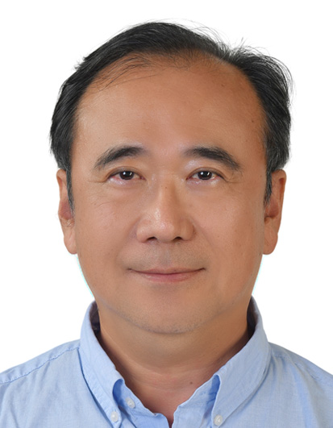
DR. CHOU, CHING-AN
Curriculum Vitae

Education
- Bachelor of Science in Horticulture, National Taiwan University
- Master of Science, Department of Floriculture and Ornamental Horticulture, Cornell University, USA
- Ph.D. in Horticulture, Graduate Institute of Horticulture, National Taiwan University
Professional Experience
- Government Sector – Agricultural Research (1993–1994)
  - Taoyuan District Agricultural Research and Extension Station, Council of Agriculture, Executive Yuan
Responsible for the development and promotion of automated production systems for flower seedlings.

- Government Sector – Administrative and Planning Roles (1995–2016, 20 Years)
- Section Chief, Department of Agriculture, Taipei County Government
(renamed New Taipei City Government after municipal restructuring). Responsible for countywide landscape planning and implementation. Major achievements include the landscape redevelopment of Fisherman’s Wharf and Bali Left Bank, creating new and popular tourist destinations.
- Section Chief, Division of Agriculture, Forestry, Fisheries and Animal Husbandry, Department of Economic Development, Taipei City Government. Responsible for citywide agricultural policy planning and the promotion and implementation of leisure industries. Served as the lead organizing section chief for the 2010 Taipei International Flora Exposition.
- Director, Department of Commerce and Tourism, Yilan County Government. Promoted Yilan’s leisure industries, quality homestays, tourism factories, and other distinctive cultural and creative industries.
- Director, Department of Planning, Yilan County Government. Responsible for overall county development planning and performance evaluation.
- Director, Department of Agriculture, Yilan County Government. Promoted the development of specialty leisure agriculture, the sixth-industry model (integrating primary, secondary, and tertiary industries), and tourism integration.

- Major International Exposition Experience
  - Deputy Executive Director, Operations Headquarters, 2010 Taipei International Flora Exposition.Responsible for international exhibition bidding and proposal processes. Oversaw overall curatorial planning and full-park operational execution throughout the exposition.

- Academic Appointments
  - Adjunct Assistant Professor, National Ilan University
  - Adjunct Assistant Professor, Fo Guang University

- Agricultural Industry (2017–Present)
  - Developed an innovative Deep-Water Raft Culture System, advancing Smart Agriculture 4.0 with fully automated production management. This system represents a state-of-the-art vegetable cultivation model. Founded Sunlit Hydroponic Farm and Moss Creek Co., Ltd., specializing in the production of premium fresh-market lettuce, which is widely distributed through Taiwan’s largest supermarket chains.

